OWNERSHIP CERTIFICATE
To Whom It May Concern

This is to certify that the following equipment listed below is the sole property of Sudhir Equipment Rental Company:

Equipment | AWP
Brand / Make | DINGLI
Asset ID | SD10ESL-2642
Model Number | S1008AC+
Serial Number | JPAC125F02245
Working Height | 10 Meter
Type | ELECTRIC SCISSOR LIFT
Manufacturing Year | 2025

This certification is issued to confirm the ownership status of the aforementioned equipment. Sudhir Equipment Rental Company holds full legal ownership rights over the listed equipment and retains all associated benefits and responsibilities.
Should there be any queries or requests for verification regarding the ownership of the mentioned equipment, please do not hesitate to contact us at: Info@sudhirrentals.com

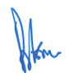
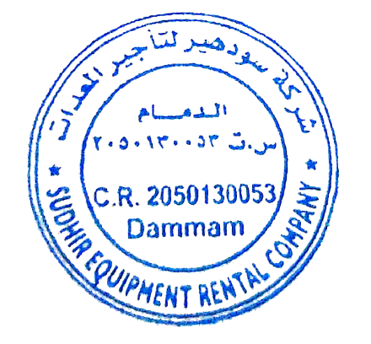
sincerely,

Rajesh Thakur
Plant Manager
Sudhir Equipment Rental Company

